DATABASE SYSTEM ENGINEERING AND DISTRIBUTED BACKEND DEVELOPMENT

SKILL SESSION 4 — LAB RECORD

Student Name | Teja Hasini Reddy
Roll Number | 2520030048
Section | 7
Course | Database System Engineering and Distributed Backend Development (25CS1302E)
Experiment Title | Bank Transaction Management Using MongoDB Atlas Data Explorer
Platform | MongoDB Atlas — Data Explorer
Database | bankdb

3. Procedure
STEP 1: Create the Database and First Collection
Database Name : bankdb Collection Name : customers

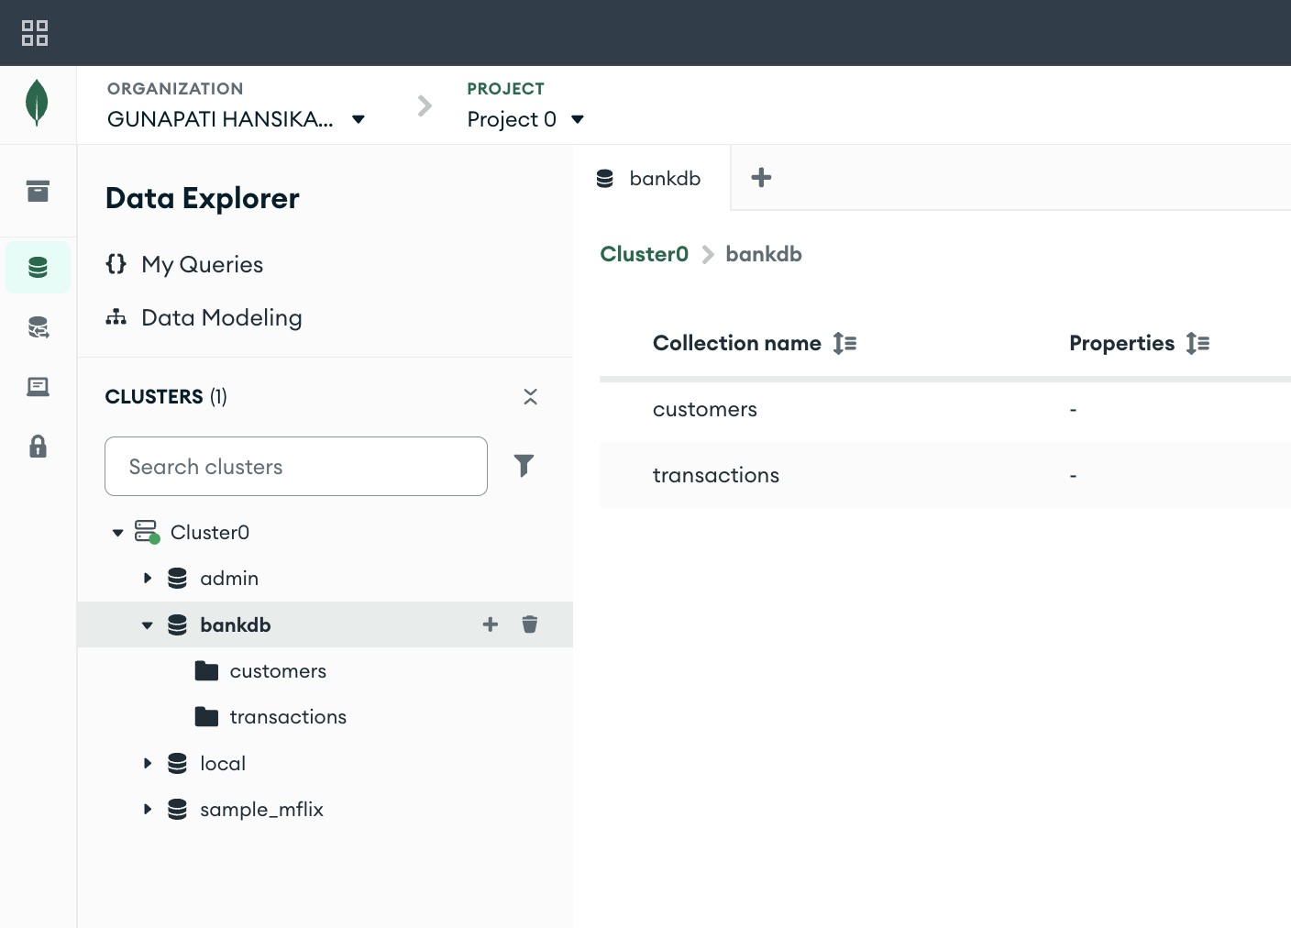

Step 2: Insert Customer Data (8 Documents)
Open bankdb → customers → Documents. Click Add Data → Insert Document. Insert each of the following JSON documents one at a time, then click Insert.
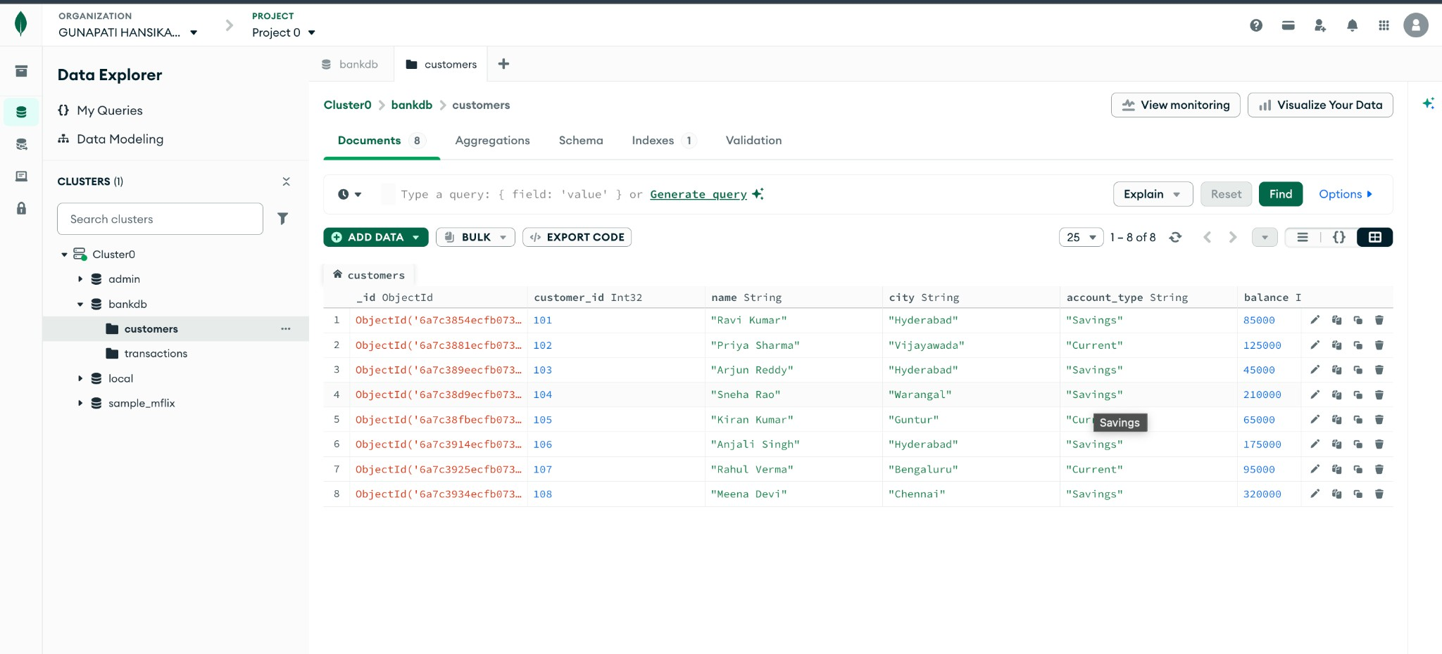
{ "customer_id": 101, "name": "Ravi Kumar", "city": "Hyderabad", "account_type": "Savings", "balance": 85000, "status": "Active" }

{ "customer_id": 102, "name": "Priya Sharma", "city": "Vijayawada", "account_type": "Current", "balance": 125000, "status": "Active" }

{ "customer_id": 103, "name": "Arjun Reddy", "city": "Hyderabad", "account_type": "Savings", "balance": 45000, "status": "Active" }

{ "customer_id": 104, "name": "Sneha Rao", "city": "Warangal", "account_type": "Savings", "balance": 210000, "status": "Active" }

{ "customer_id": 105, "name": "Kiran Kumar", "city": "Guntur", "account_type": "Current", "balance": 65000, "status": "Inactive" }

{ "customer_id": 106, "name": "Anjali Singh", "city": "Hyderabad", "account_type": "Savings", "balance": 175000, "status": "Active" }

{ "customer_id": 107, "name": "Rahul Verma", "city": "Bengaluru", "account_type": "Current", "balance": 95000, "status": "Active" }

{ "customer_id": 108, "name": "Meena Devi", "city": "Chennai", "account_type": "Savings", "balance": 320000, "status": "Active" }

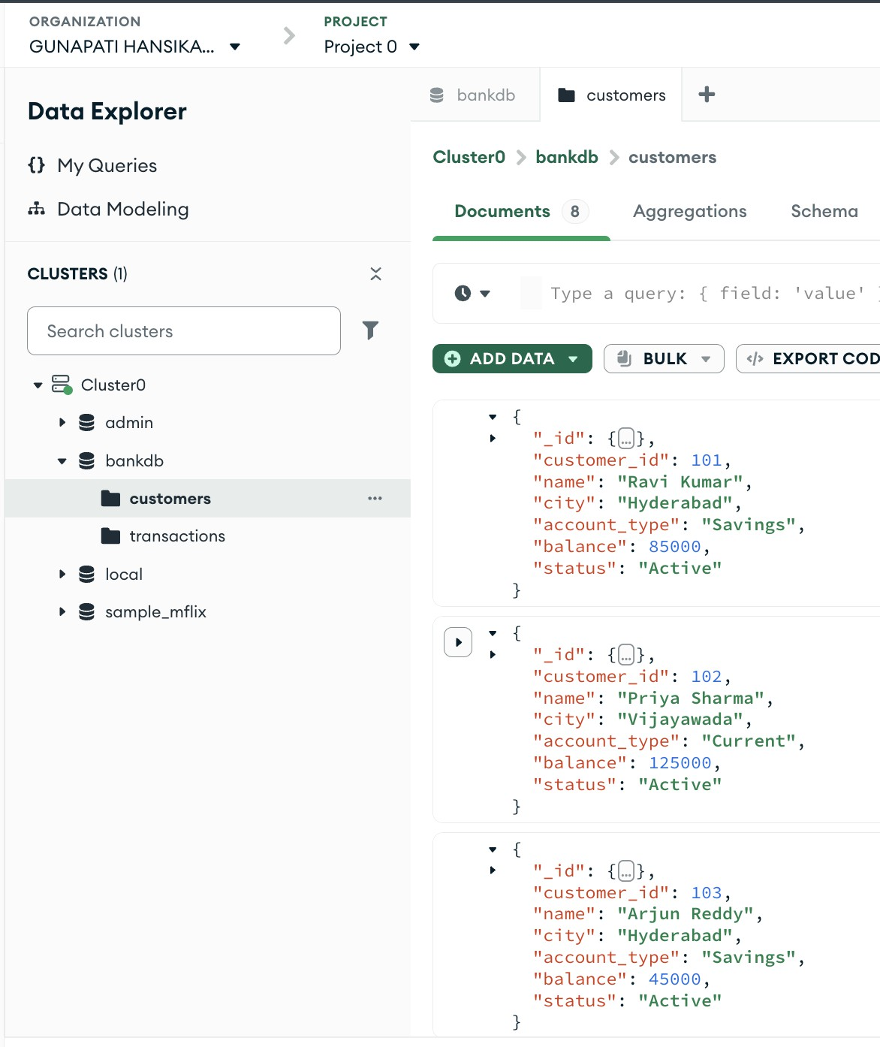
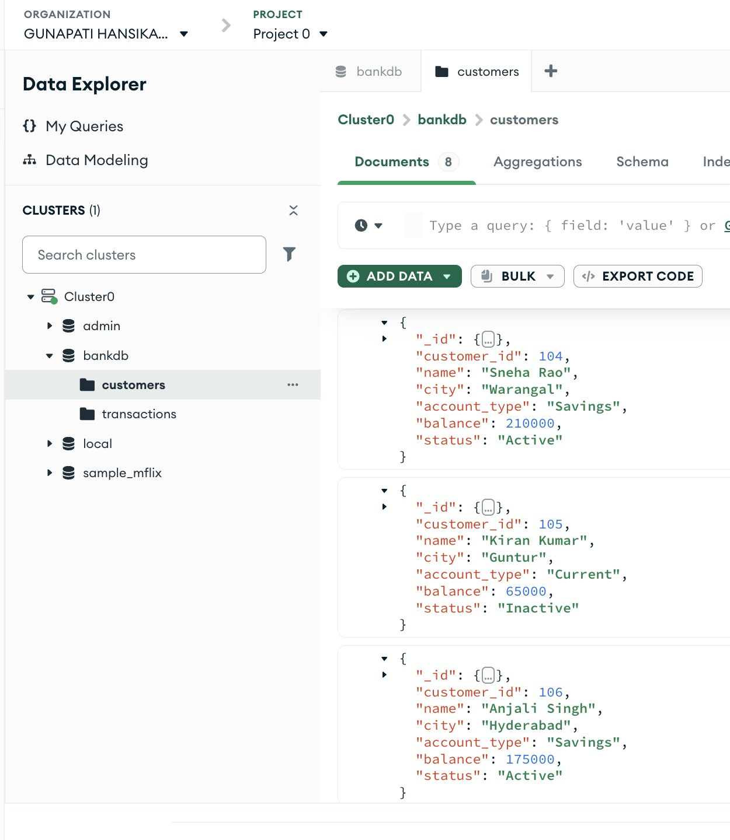

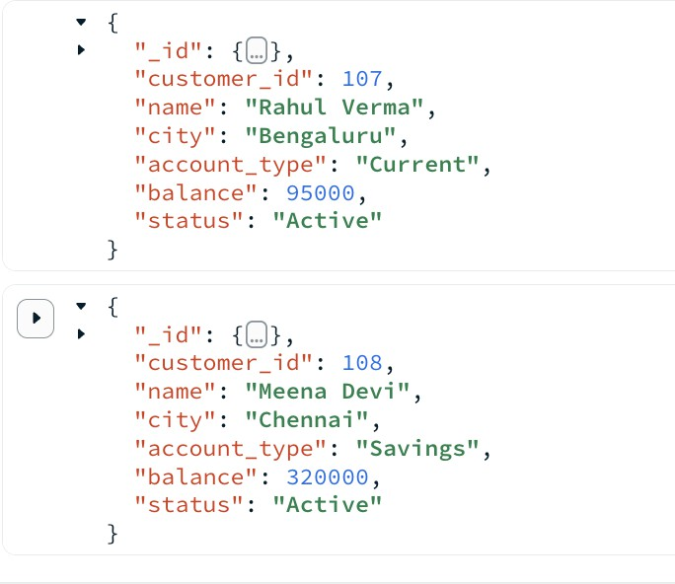

Step 3 : Insert Transaction Data (15 Documents)
Open bankdb → transactions → Documents. Click Add Data → Insert Document. Insert each transaction JSON one at a time.

{ "transaction_id": 1001, "customer_id": 101, "type": "Deposit",
"amount": 25000, "mode": "UPI", "date": "2026-08-01", "status": "Success" }

{ "transaction_id": 1002, "customer_id": 101, "type": "Withdrawal", "amount": 10000, "mode": "ATM", "date": "2026-08-02", "status": "Success" }

{ "transaction_id": 1003, "customer_id": 102, "type": "Deposit",
"amount": 50000, "mode": "NEFT", "date": "2026-08-02", "status": "Success" }

{ "transaction_id": 1004, "customer_id": 102, "type": "Withdrawal", "amount": 15000, "mode": "ATM", "date": "2026-08-03", "status": "Success" }

{ "transaction_id": 1005, "customer_id": 103, "type": "Deposit",
"amount": 30000, "mode": "UPI", "date": "2026-08-03", "status": "Success" }

{ "transaction_id": 1006, "customer_id": 103, "type": "Withdrawal", "amount": 5000, "mode": "ATM", "date": "2026-08-04", "status": "Success" }

{ "transaction_id": 1007, "customer_id": 104, "type": "Deposit",
"amount": 100000, "mode": "NEFT", "date": "2026-08-04", "status": "Success" }

{ "transaction_id": 1008, "customer_id": 104, "type": "Withdrawal", "amount": 25000, "mode": "ATM", "date": "2026-08-05", "status": "Success" }

{ "transaction_id": 1009, "customer_id": 105, "type": "Deposit",

"amount": 15000, "mode": "UPI", "date": "2026-08-05", "status": "Success" }

{ "transaction_id": 1010, "customer_id": 106, "type": "Deposit",
"amount": 75000, "mode": "NEFT", "date": "2026-08-06", "status": "Success" }

{ "transaction_id": 1011, "customer_id": 106, "type": "Withdrawal", "amount": 20000, "mode": "ATM", "date": "2026-08-06", "status": "Success" }

{ "transaction_id": 1012, "customer_id": 107, "type": "Deposit",
"amount": 40000, "mode": "IMPS", "date": "2026-08-07", "status": "Success" }

{ "transaction_id": 1013, "customer_id": 107, "type": "Withdrawal", "amount": 12000, "mode": "ATM", "date": "2026-08-07", "status": "Success" }

{ "transaction_id": 1014, "customer_id": 108, "type": "Deposit",
"amount": 150000, "mode": "NEFT", "date": "2026-08-08", "status": "Success" }

{ "transaction_id": 1015, "customer_id": 108, "type": "Withdrawal", "amount": 30000, "mode": "ATM", "date": "2026-08-08", "status": "Success" }

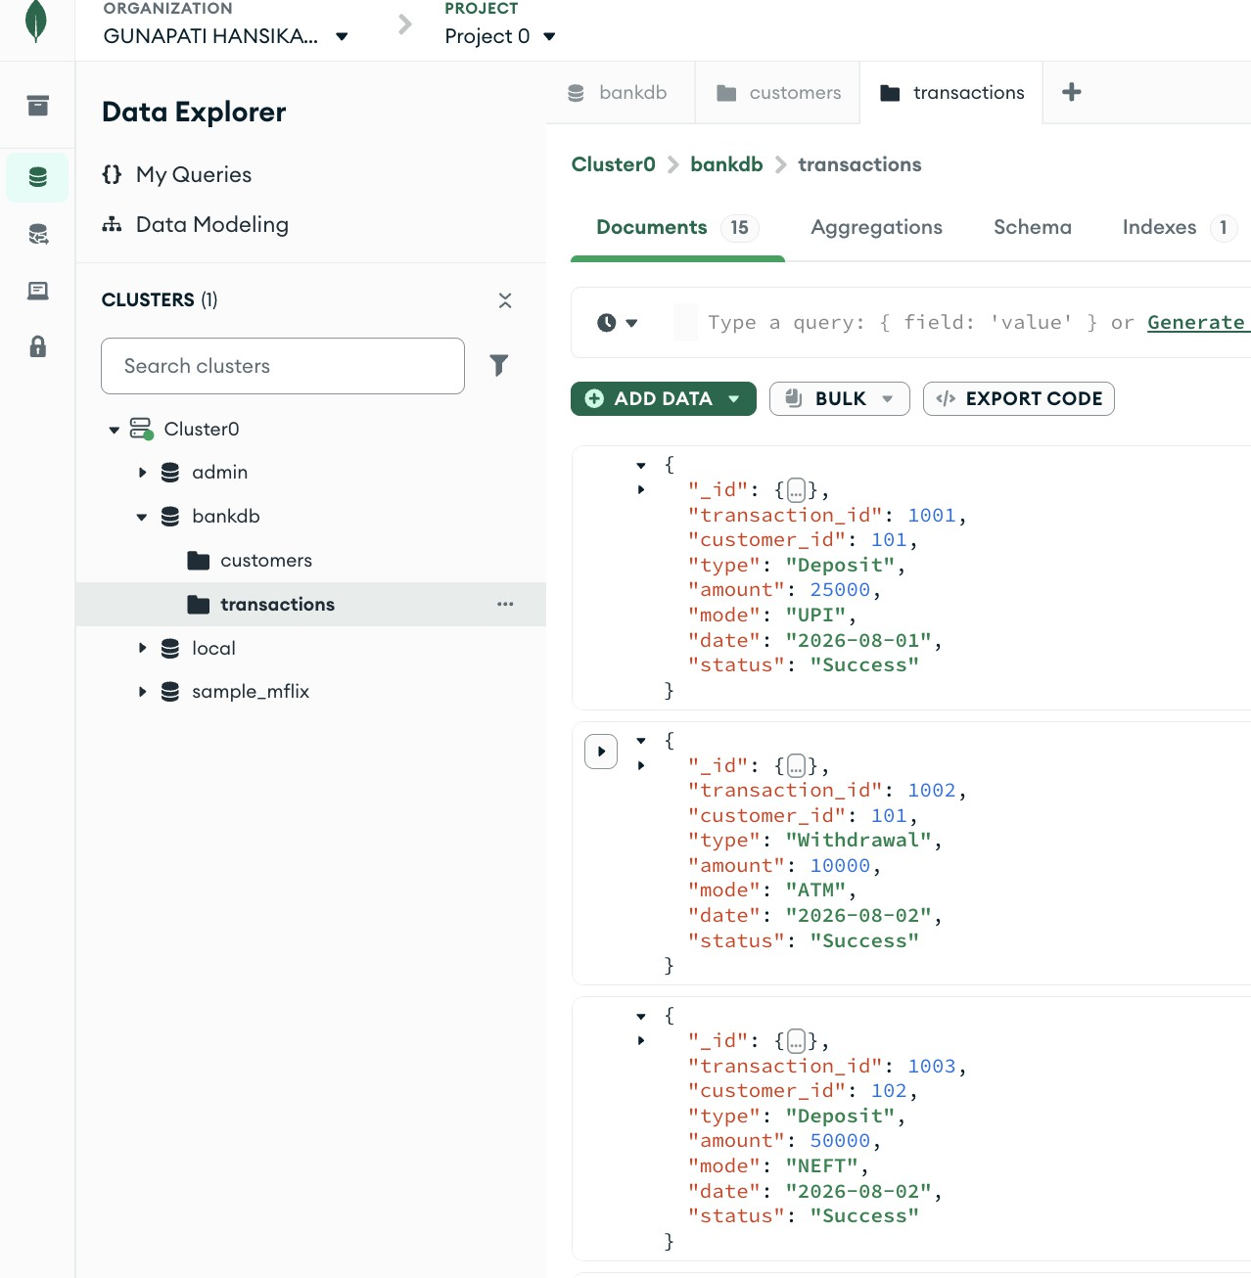

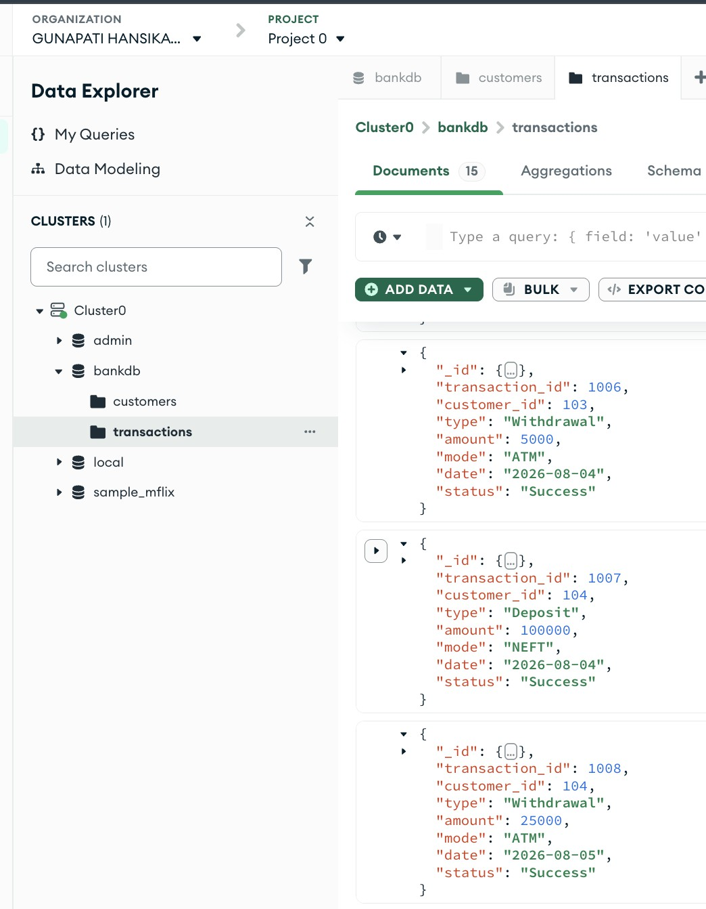

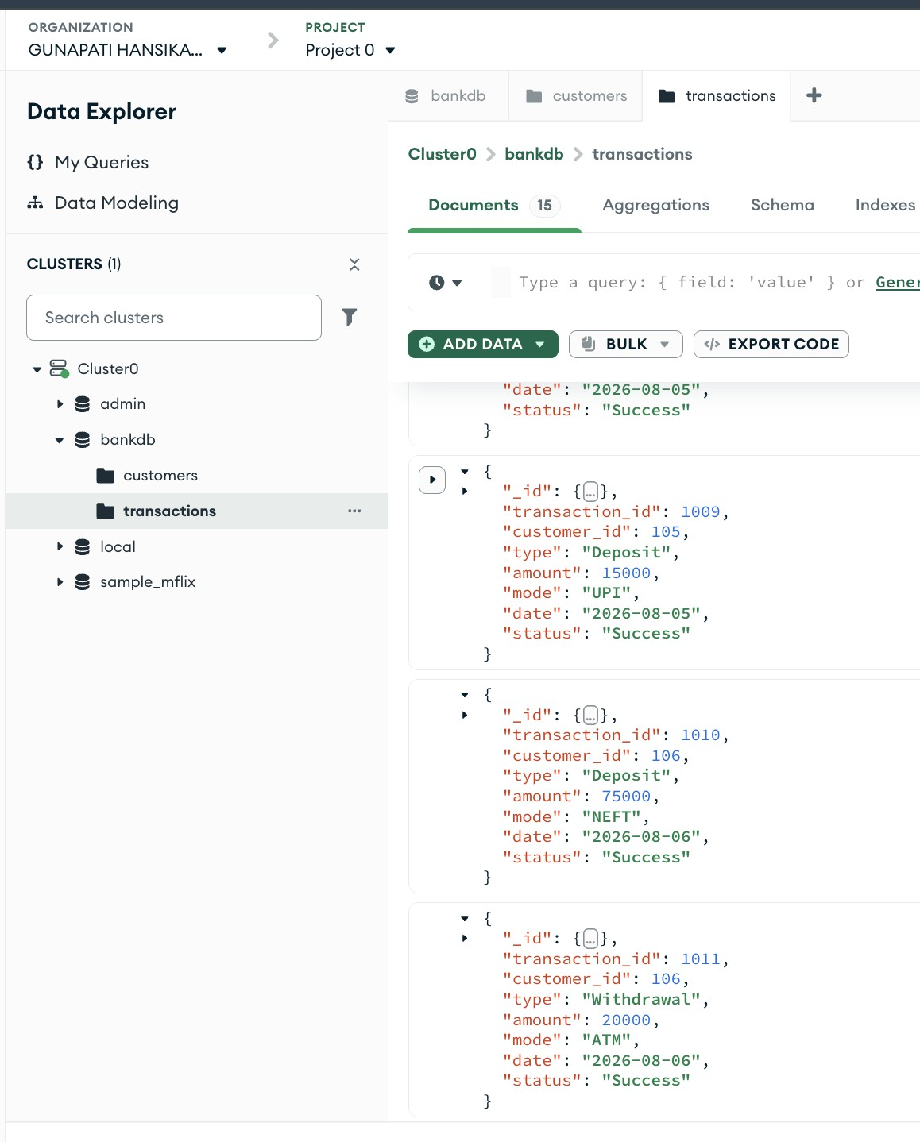

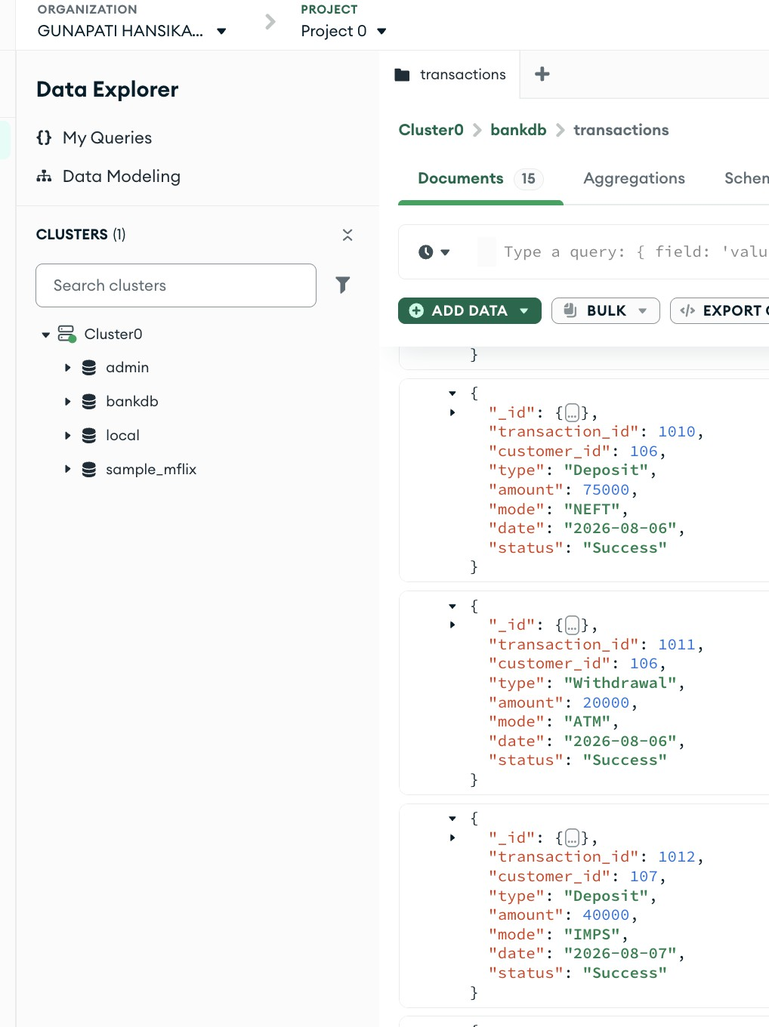

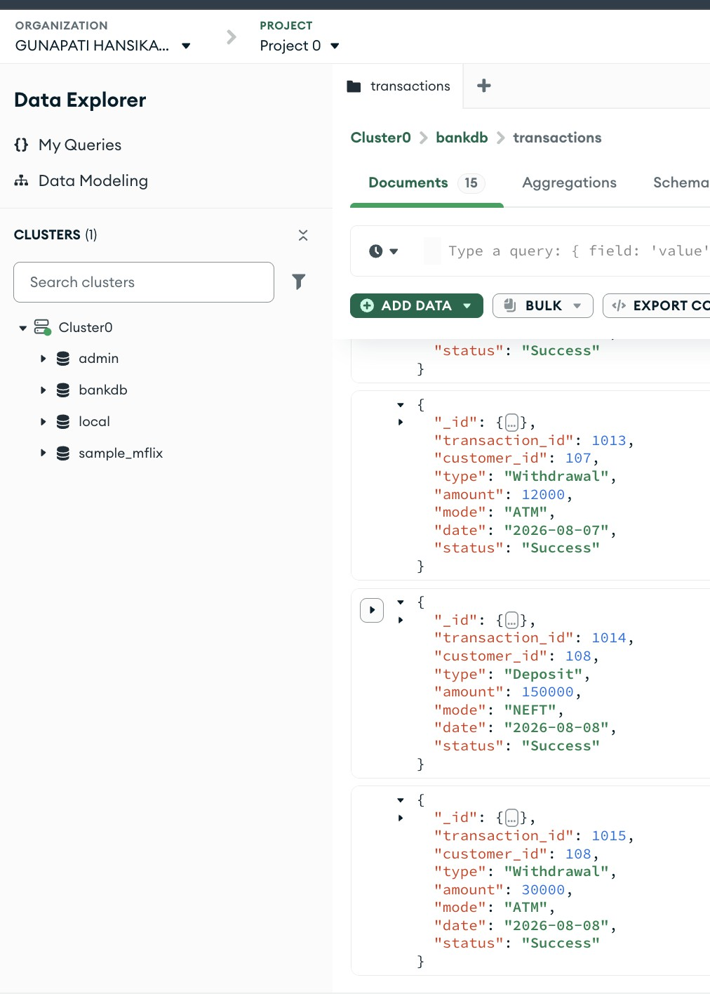

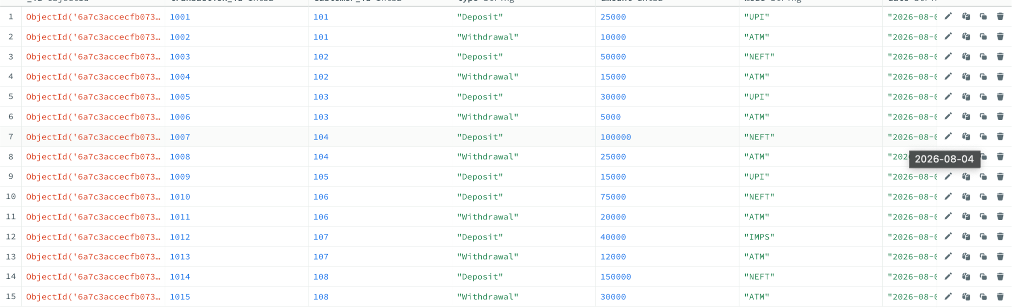

Basic Find Queries (Q1 – Q11)
For each query below: open the collection → Documents tab → paste the filter JSON into the Filter box
→ click Find.

Query 1: Display All Customers

Collection: customers
{}

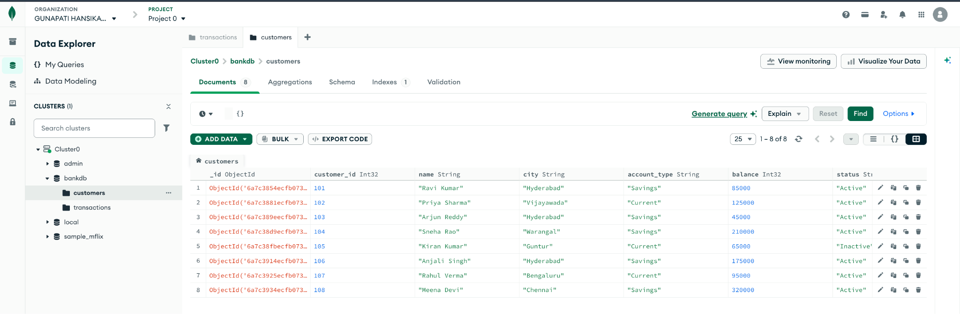

Query 2: Find Active Customers

Collection: customers
{ "status": "Active" }

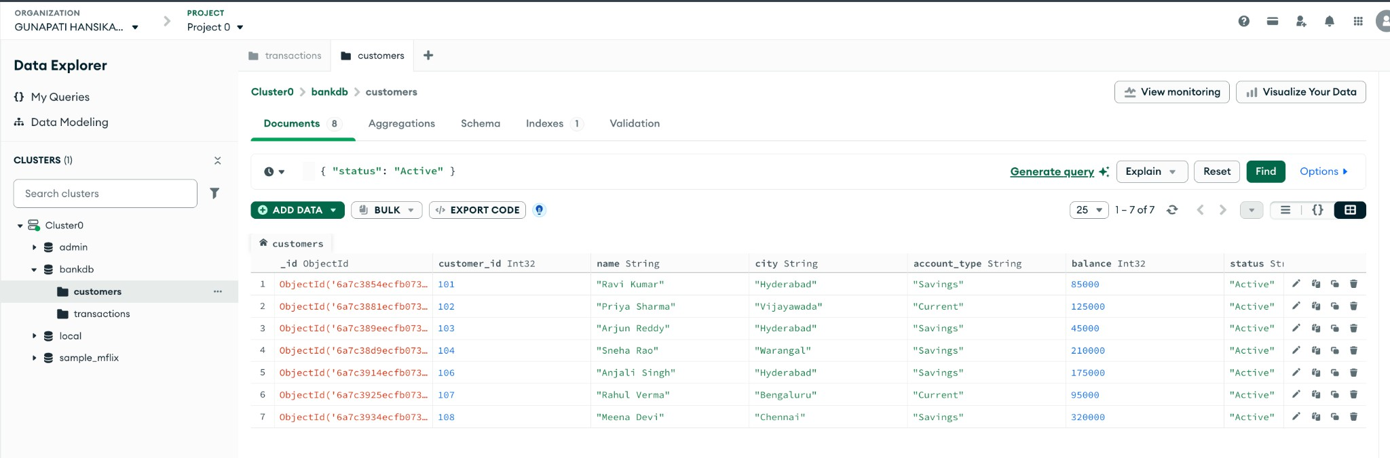
Query 3: Find Customers with Balance > 100000

Collection: customers
{
"balance": { "$gt": 100000 } }

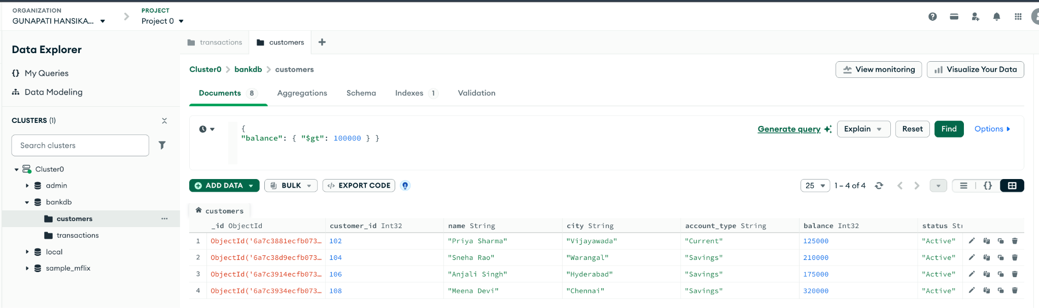

Query 4: Find Hyderabad Customers

Collection: customers
{ "city": "Hyderabad" }

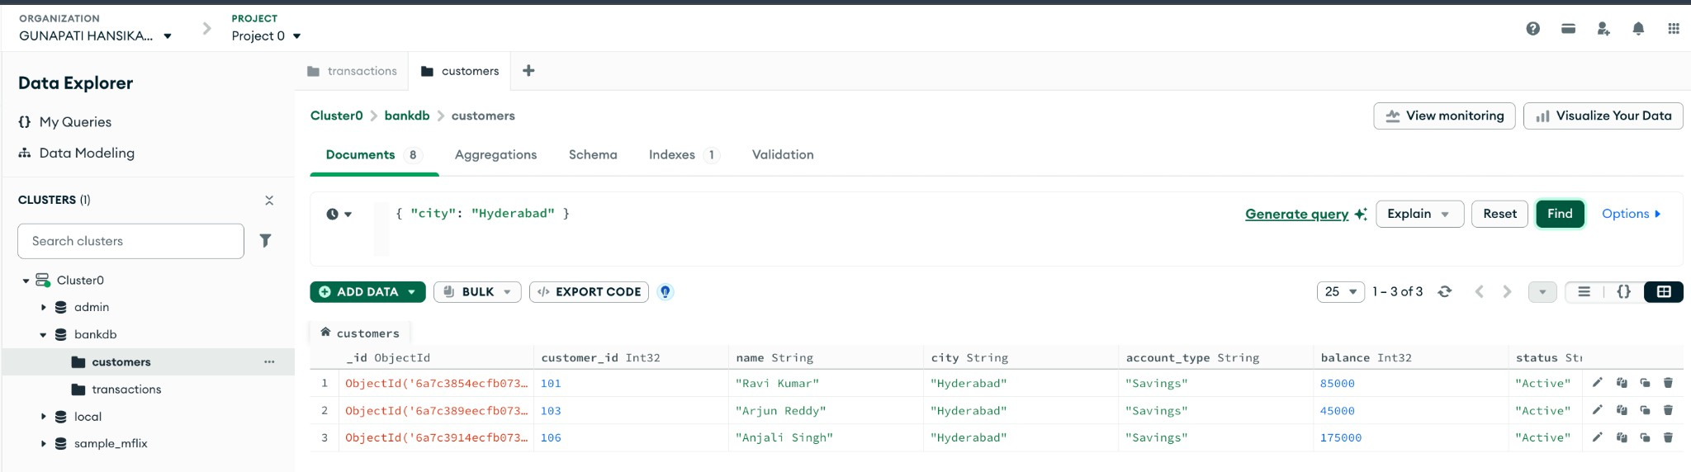

Query 5: Find Savings Account Customers

Collection: customers
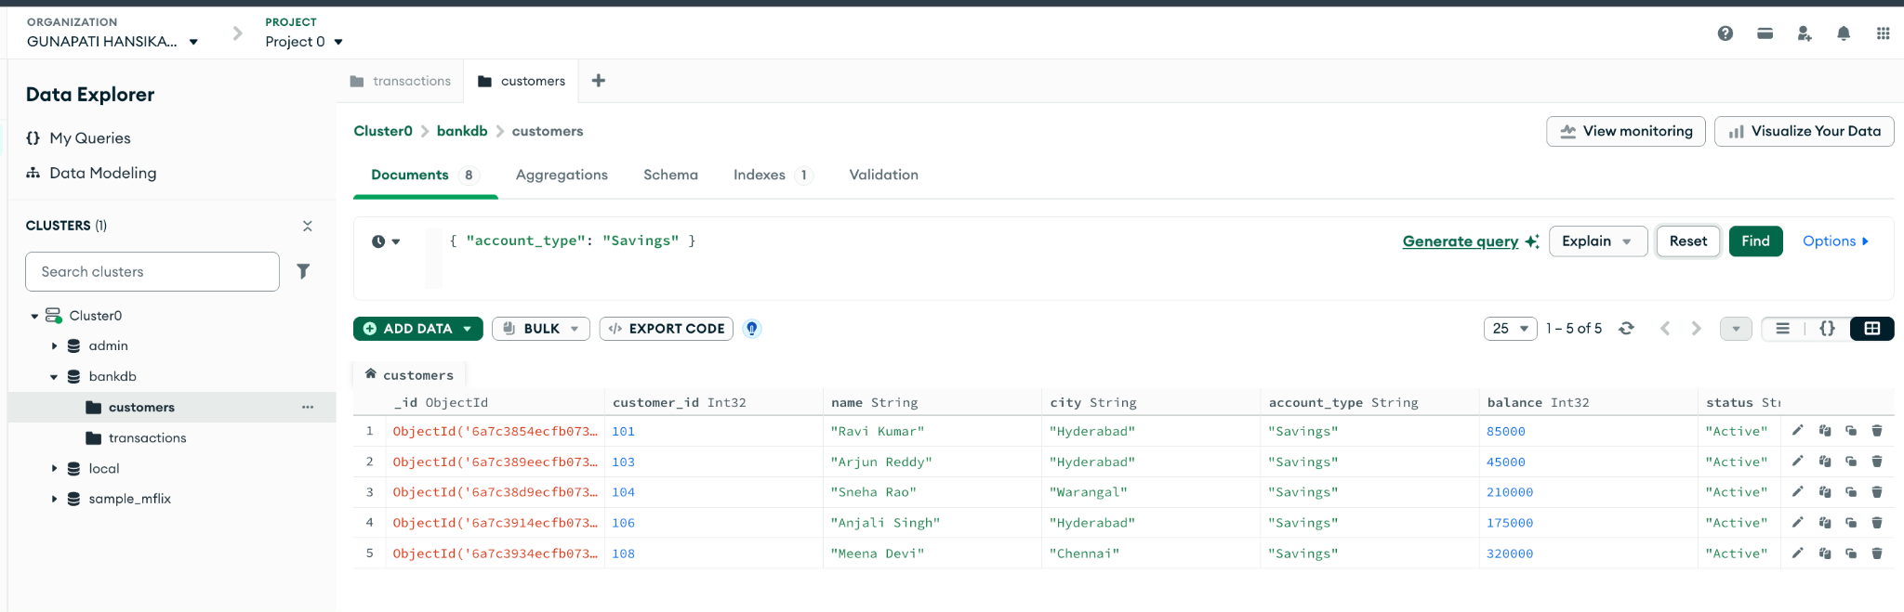
{ "account_type": "Savings" }

Query 6: Find Transactions Greater Than 20000

Collection: transactions
{ "amount": { "$gt": 20000 } }

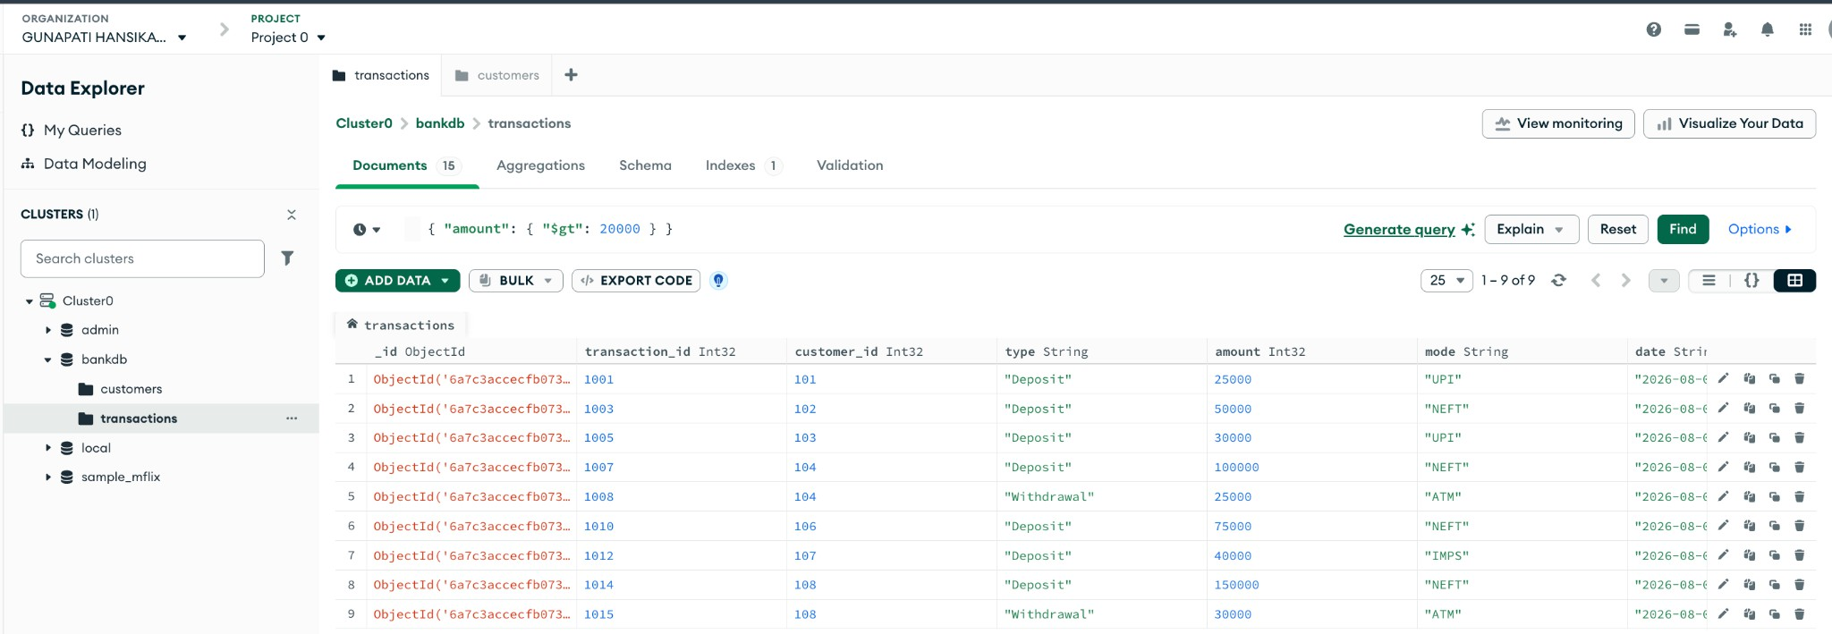

Query 7: Find Deposits

Collection: transactions
{ "type": "Deposit" }

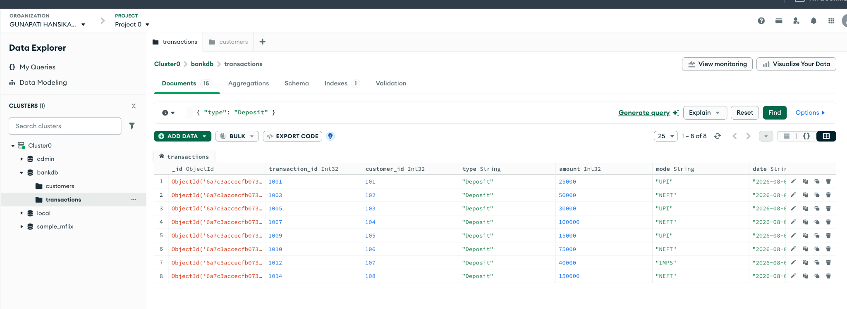

Query 8: Find ATM Transactions

Collection: transactions
{ "mode": "ATM" }

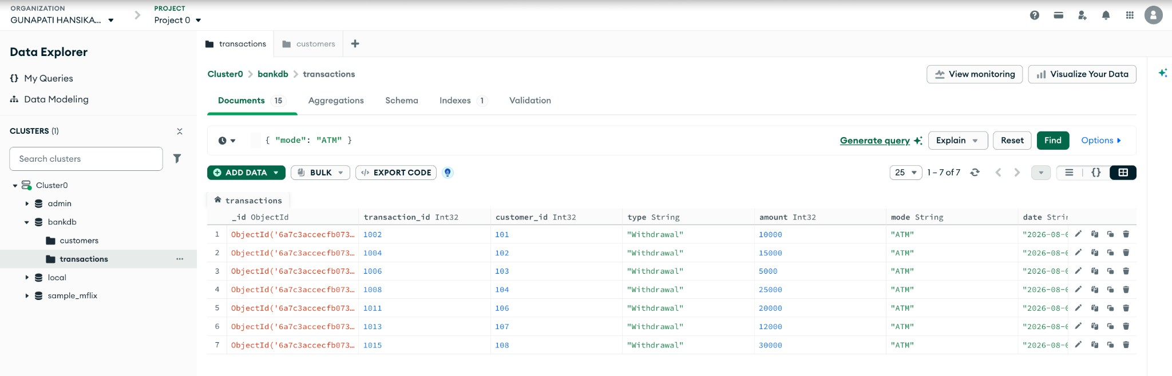

Query 9: Find Deposits Greater Than 50000

Collection: transactions
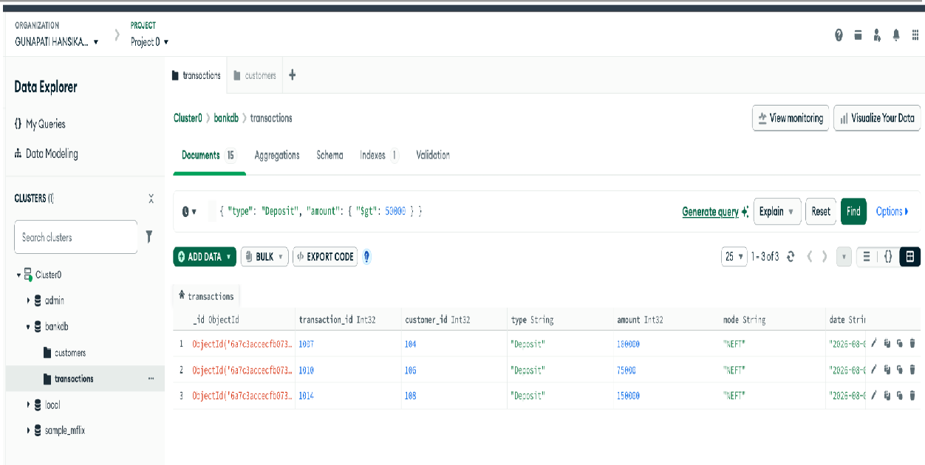
{ "type": "Deposit", "amount": { "$gt": 50000 } }

Query 10: Find Hyderabad Customers with High Balance

Collection: customers
{ "city": "Hyderabad", "balance": { "$gt": 100000 } }

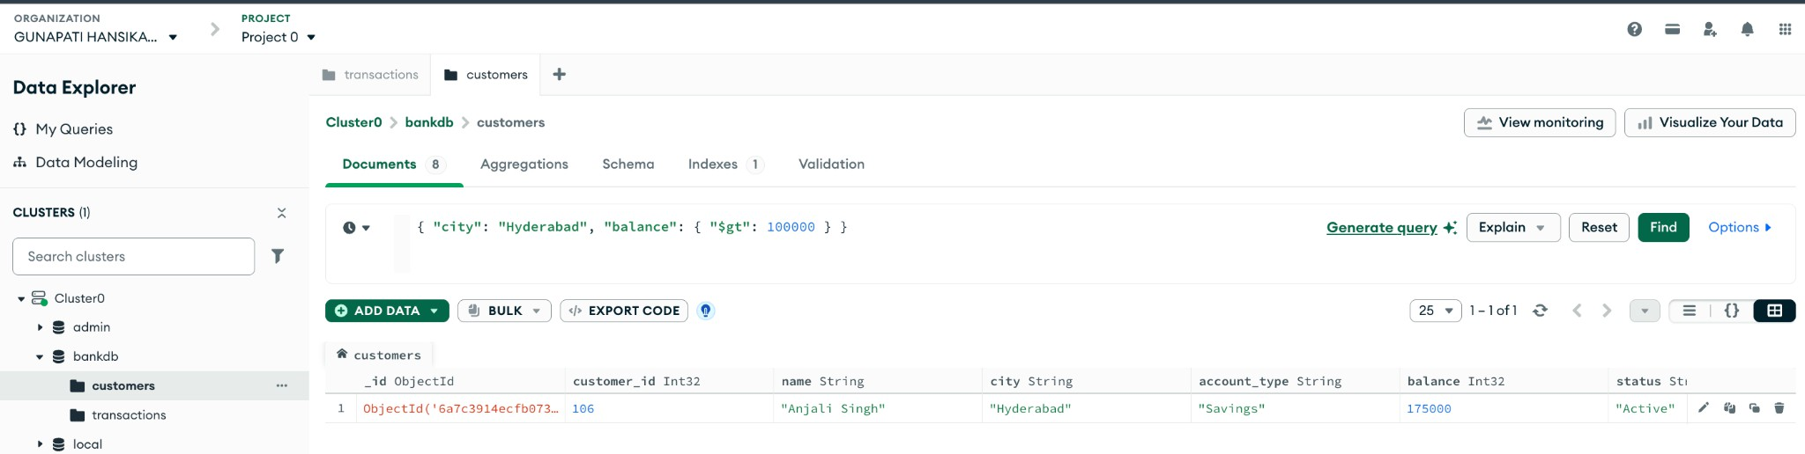

Query 11: Find Customers in Multiple Cities

Collection: customers
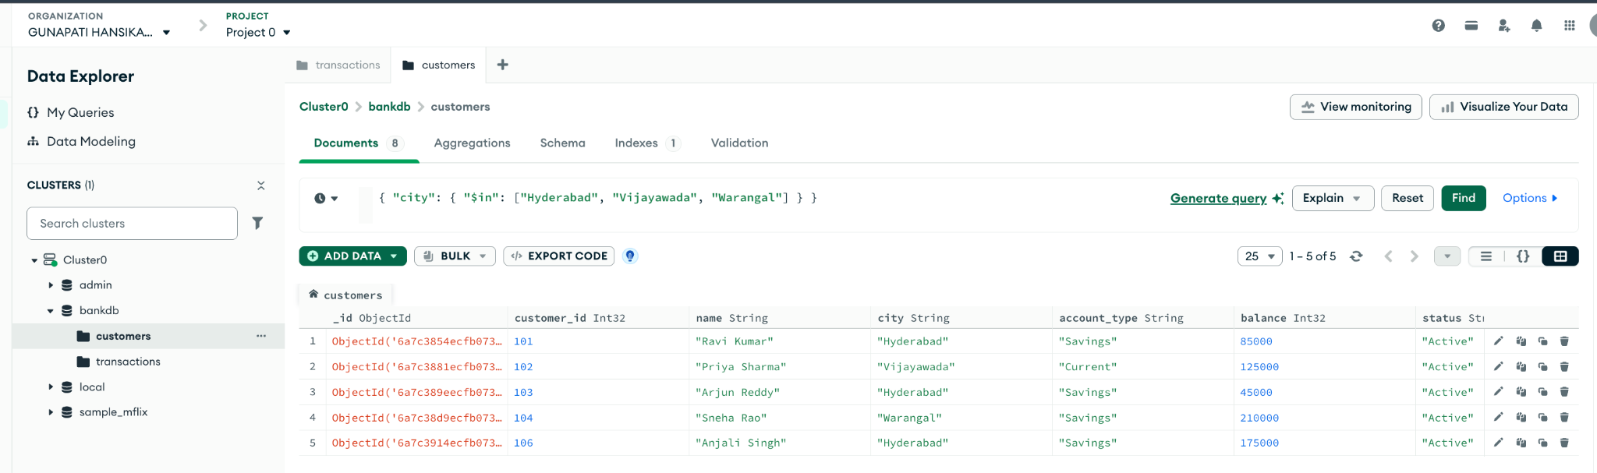
{ "city": { "$in": ["Hyderabad", "Vijayawada", "Warangal"] } }

